|  |  |  |  |  |
| --- | --- | --- | --- | --- |
| **Q1** | **Q2** | **Q3** | **Q4** | **Total** |
|  |  |  |  |  |

**Student Name:** ______________________ **Number:** __________________

**Yıldız Technical University**

**BLM4800–Introduction to Data Mining**

**Final Exam - Spring 2022-2023**

* **Duration:** 90 minutes
* **Exam information:**
  + Attempts to cheat in the exam will not be tolerated. If an attempt to cheat is discovered, it will be severely punished.
  + Read all the questions carefully before you start answering them.
  + The point value of each question is indicated next to the question.

a-)In the field of neural networks, all activation functions inside the model must also be linear for the output to demonstrate linearity, a principle that denotes a straight proportionality between input and output. These activation functions are vital because they control how information moves through the network, basically changing a node's input signal into an output signal. As a result, the model's overall behavior is directly impacted by the linearity of these activation functions.

b-)The result strongly implies that a binary result is what is expected. This is made feasible by the neural network's integration of the sigmoid activation function (S(alpha)). Further, we may draw a parallel with the preceding explanation when we look at the input of the last layer, which follows a linear equation (B1 X1 + B2 X2). This suggests that the interior layers should have precisely linear activation functions (L) while designing them.

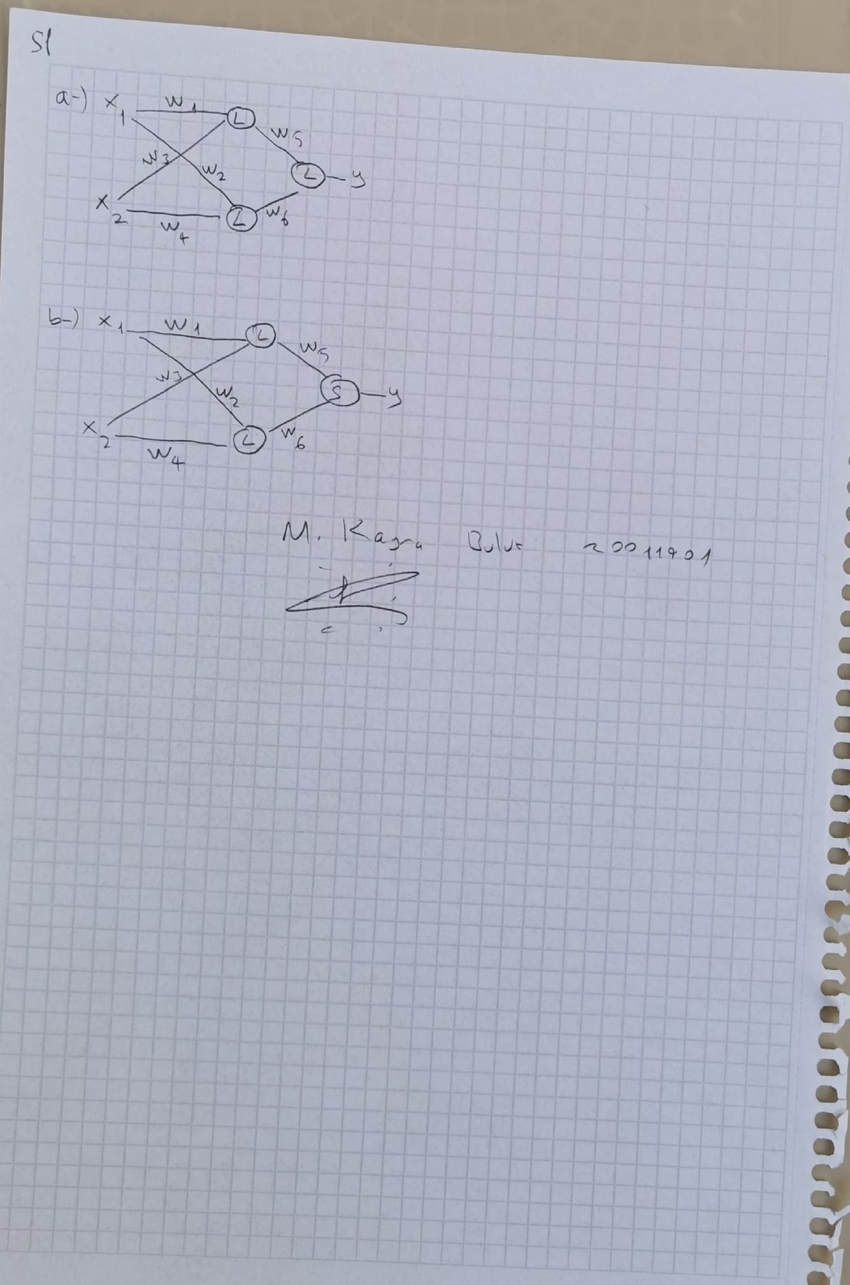

|  |  |  |
| --- | --- | --- |
| Data | Cluster Assignment After First Iteration | Cluster Assignment After Second Iteration |
| 1 |  |  |
| 2 |  |  |
| 3 |  |  |
| 4 |  |  |
| 5 |  |  |
| 6 |  |  |
| 7 |  |  |
| 8 |  |  |
| 9 |  |  |
| 10 |  |  |

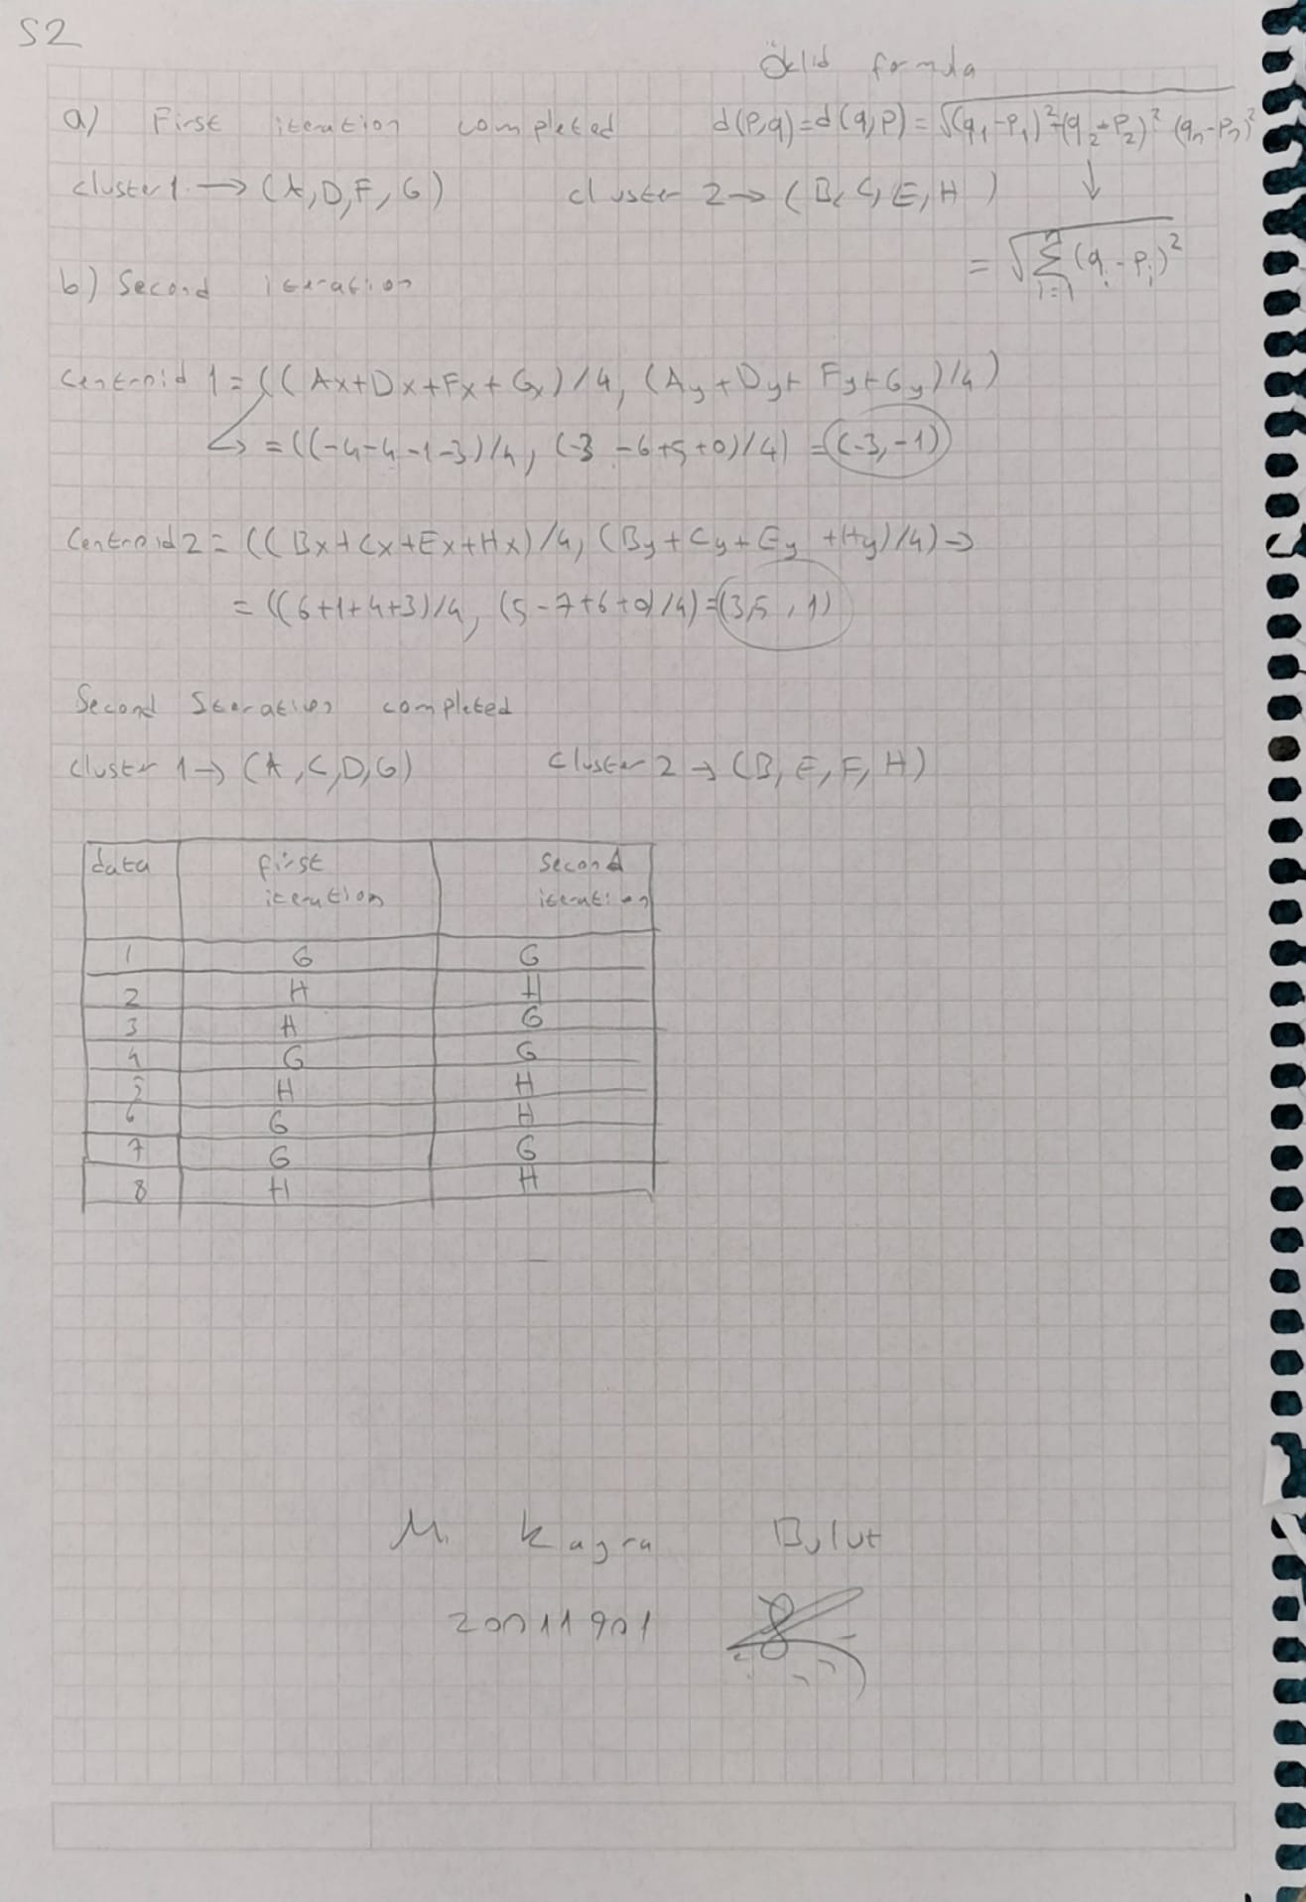



We write all the elements whose number of bags is higher than 2

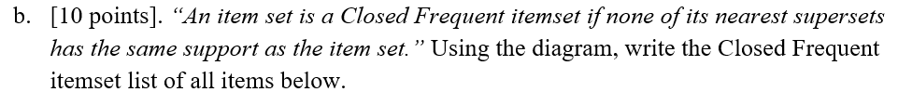

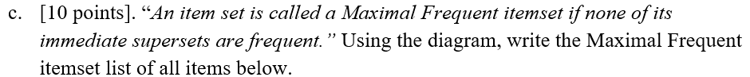

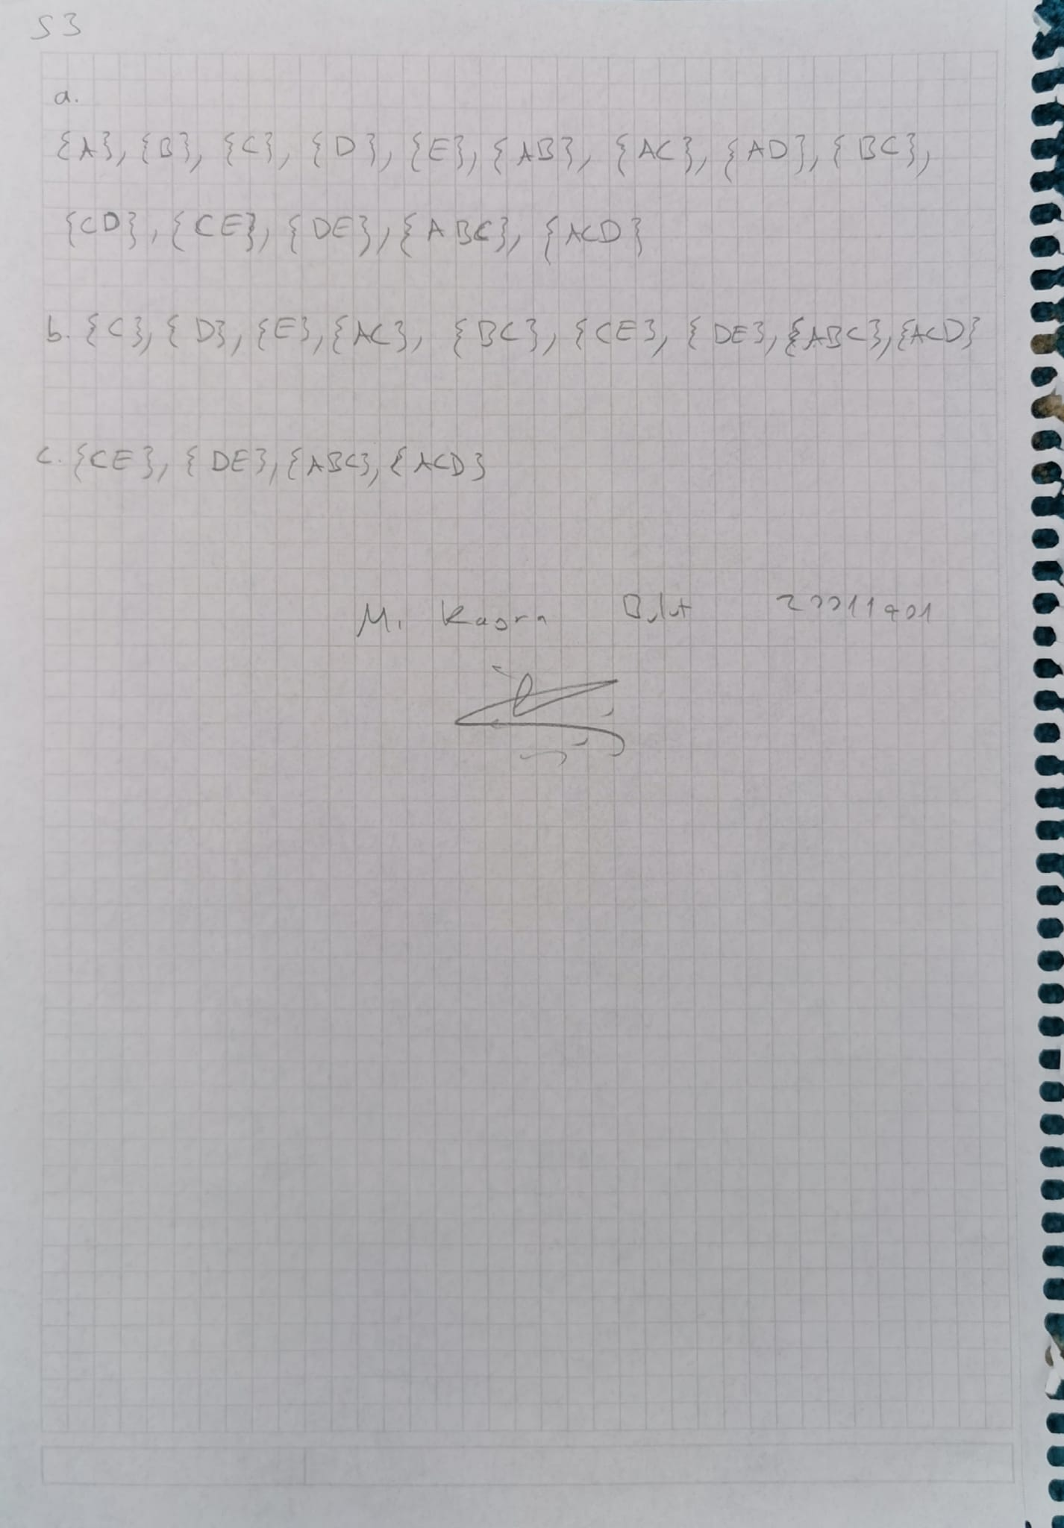

To reduce the dimensionality of the provided data, principle Component Analysis (PCA) allows one to transfer data points onto the principle components, which are effectively vectors. The axes that capture the most variety in the data are the major components.

This particular situation involves projecting a 2D dataset (X, Y) onto the first main component, represented by the vector (0.59, 0.81), in order to reduce it to a 1D set.

The mathematical procedure known as "dot product" can be used to project a point (x, y) onto a vector (u, v).

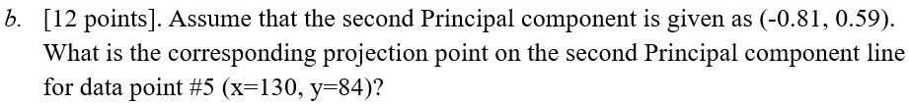

The projection of a data point onto the second principal component may also be determined using the dot product formula, much as the preceding approach.

We start by determining the second main component's unit vector. We may accept the vector (-0.81, 0.59) as a unit vector since its magnitude is substantially close to 1 (rounding mistakes apart).

We may calculate the projection of this data point onto the second main component by calculating the dot product of the data point (130, 84) and the unit vector (-0.81, 0.59).

metin, defter, kağıt, el yazısı içeren bir resim

Açıklama otomatik olarak oluşturuldu